
PUNJAB ENGINEERING COLLEGE CHANDIGARH
(DEEMED TO BE UNIVERSITY)

PBAS Performa for Promotion under the CAS as per 4th amendment 11.07.2016
(As per UGC norms)
Application for promotion from ……………………………………. to………………………….
{Assistant Professor (Stage 1 to Stage 2, Stage 2 to Stage 3), Assistant Professor (Stage 3) to Associate Professor (Stage 4), Associate Professor (Stage 4) to Professor/equivalent cadres Stage 5)}.
(Please indicate whichever is applicable)
PART A : GENERAL INFORMATION AND ACADEMIC BACKGROUND
Date of joining PEC on regular basis_______________ Post_____________
Department____________
Post presently held: Department:
Date of joining this post on regular basis:
Post to which promotion is sought:
Date of eligibility for promotion:
(on the basis of Service and Academic Performance Requirement)

Initial Assessment Period: From……………….. to…………………………….
Subsequent Additional Assessment Period (If applicable): (Please refer 6.3.2 of UGC regulations 2010)
(i) From……………….. to…………………………….
(ii) From……………….. to…………………………….
(iii) From……………….. to…………………………… ____________________________________________________________________________________
1. Name in Full: (Underline Surname)
Affix passport size photograph

2. Address: For correspondence Permanent
_________________ ______________________ _________________ ______________________

Phone _______________________ Fax No. __________ E-mail ID_______________________

3. Date of Birth: 4. Nationality: 5.Gender: __________________________________________________________________________________
6. Category: General /SC/ST/OBC: ______________________________________________________________________________________
7. Area of Specialization:…………………………………………..

8. Current area of Research:……………………………………… ________________________________________________________________________________________

9. Academic Qualifications (Matric till post graduation):
Examinations |  | Name of the Board/ University | Year of Passing | Percentage of Marks Obtained | Division/Class/  Grade | Subject(s)
High School/Matric/ /Secondary
Intermediate/ Sr Secondary
Graduation
Post Graduation | MA/MSc
Post Graduation | M.Tech/ MPhil
Other examinations, if any

10. Research Degree(s):

Degrees | Title | Date of Award | University
Ph.D/D. Phil.
D.Sc/D. Litt

- In case of M.Tech/ M.Phil/ Ph.D. Examination, an attested copy of the degree & the result notification for the same be attached.

For the following items use separate sheets wherever required in the format indicated. All annexures should be consecutively arranged and must bear your name and authenticated with your signature.
11. Appointments held prior to joining the Punjab Engineering College (Deemed to be University) Chandigarh :(Please attach relevant certificates of service experience)
Institute | Designation | Essential qualifications for the post at the time of appointment | Nature of  appointment (Regular/ Fixed term/Temporary / Adhoc /Contractual) | Nature of  Duties | Pay-  Scale | Date |  | Total Duration |  |  | Reason of Leaving
 |  |  |  |  |  | From | to | Y | M | D | Reason of Leaving

12. Post(s) held after appointment at the Punjab Engineering College (Deemed to be University) Chandigarh :

Designation | Essential qualifications for the post at the time of appointment | Nature of appointment (Regular/ Fixed term / Temporary/ Adhoc/Contractual) | Nature of Duties | Pay-  Scale | Date |  | Total duration
 |  |  |  |  | From | to | Y | M | D

13. Period/Duration of teaching experience: From……………to…………. Total duration
P.G. Classes (in years) …………. U.G. Classes (in years) ………..

14. Research Experience excluding years spent in MTech/ M.Phil/ Ph.D (in years)…………

15. Academic Staff College Orientation/Refresher and other Courses* attended: (Attach certificates in chronological order)
Name of the Course | Place | Period |  | Duration | Sponsoring Agency
Name of the Course | Place | From | To | Total | Sponsoring Agency
* summer/ winter schools/ short term course/ other appropriate continuing education programmes of comparable quality as may be specified or approved by AICTE

16. List of Publications (in chronological order) to be sent for the purpose of evaluation - (Please attach full papers including cover page):

Sr.No. | Authors | Title | Journal | Publisher | Location | ISSN/ISBN | Impact factor | Year of Publication
1
2
3
4
5

PART B : ACADEMIC PERFORMANCE INDICATORS

(Please see detailed instructions of UGC regulations 2010 for PBAS proforma before filling this Section. In particular refer 6.3.0 of UGC regulations. Use separate sheets wherever required in the format indicated below. All annexures should be consecutively arranged and must bear your name and authenticated with your signature.)
CATEGORY : I. TEACHING, LEARNING AND EVALUATION RELATED ACTIVITIES (for calculation /eligibility see Annexure -I)

Nature of Activiity | 2010-11  (i) | 2011-12  (ii) | 2012-13  (iii) | 2013-14  (iv) | 2014-15  (v) | 2015-16  (vi) | 2016-17  (vii) | Avg of  (i) & (ii) | Avg of  (i), (ii) & (iii) | Avg of  (i), (ii), (iii) & (iv) | Avg of  (i),(ii),(iii), (iv)  & (v) | Avg of  (i),(ii), (iii),(iv),  (v) & (vi) | Avg of  (i), (ii), (iii), (iv), (v), (vi) & (vii)
a. Direct Teaching

b. Examination duties (question paper setting, Invigilation, evaluation of answer scripts) as per allotment

c. Innovative Teaching – learning methodologies, updating of subject contents/ courses, mentoring etc.

CATEGORY: II. PROFESSIONAL DEVELOPMENT, CO-CURRICULAR AND EXTENSION ACTIVITIES (for calculation/eligibility see Annexure I)

Please mention your contribution to any of the following:

S. No. | Type of Activity | API Score during Academic year
S. No. | Type of Activity | 2010-11  (i) | 2011-12  (ii) | 2012-13  (iii) | 2013-14  (iv) | 2014-15  (v) | 2015-16  (vi) | 2016-17  (vii) | Avg of  (i)& (ii) | Avg of  (i), (ii) & (iii) | Avg of  (i),(ii), (iii)& (iv) | Avg of  (i),(ii), (iii), (iv) & (v) | Avg of  (i),(ii), (iii),(iv), (v) & (vi) | Avg of (i), (ii), (iii), (iv), (v), (vi) & (vii)
- 1a | Student related co-curricular, extension and field based activities.  - Discipline related co-curricular activities (e.g remedial classes, career counseling, study visit, student seminar and other events.)  - Other co-curricular activities (Cultural, Sports, NSS, NCC etc.)  - Extension and (dissemination activities (public/popular lectures /talks/seminars etc.)
b. | Contribution to corporate life and management of the department and institution through participation in academic and administrative committees and responsibilities.  (i) Administrative responsibility (including as Dean/Principal/ Chairperson/Convener/ Teacher- in-charge/ similar other duties that require regular office hrs for its discharge)  (ii) Participation in Board of Studies, Academic and Administrative Committees
c. | Professional Development activities (such as participation in seminars, conferences, short term training courses, industrial experience, talks, lectures in refresher/faculty development courses, dissemination and general articles and any other contribution)

CATEGORY : III. RESEARCH PUBLICATIONS AND ACADEMIC CONTRIBUTIONS (for calculation /eligibility see Annexure I)

Use separate sheets wherever required in the format indicated below. All annexures should be consecutively arranged in chronological order and must bear your name and authenticated with your signature.

A. Research papers (Journals etc):

S.  No. | Title with page Nos. and date of publication | Journal | Publisher | Location | ISSN/  ISBN No. | Whether peer reviewed. Impact Factor, if any | Source of Impact factor | No. and name of Co-authors | Whether you are the |  | API Score
 |  |  |  |  |  |  |  |  | First author | Corresponding Author | Initial assessment period | Subsequent additional assessment period
 |  |  |  |  |  |  |  |  |  |  |  | (i) | (ii) | (iii)
Total Score

B. (i) Articles/Chapters published in Books:

S.  No. | Title with page Nos. and date of publication | Book Title, editor & publisher | ISSN/  ISBN No. | Whether peer reviewed | No. of Co-authors | Whether you are the |  | API Score
 |  |  |  |  |  | First author | Corresponding Author | Initial assessment period | Subsequent additional assessment period
 |  |  |  |  |  |  |  |  | (i) | (ii) | (iii)
Total score

C. Research Projects

(c) (i ) Sponsored Projects
S.  No. | Title | Agency | Period | Grant/ Amount Mobilized  (Rs. Lakh) | API Score
 |  |  |  |  | Initial assessment period | Subsequent additional assessment period
 |  |  |  |  |  | (i) | (ii) | (iii)
Total Score

(c) (ii) Consultancy Projects
S.  No. | Title | Agency | Period | Grant/ Amount Mobilized  (Rs. Lakh) | Whether policy document/ patent as outcome | API Score
 |  |  |  |  |  | Initial assessment period | Subsequent additional assessment period
 |  |  |  |  |  |  | (i) | (ii) | (iii)
Total Score

(c) (iii) Project outcome /outputs
S.  No. | Title | Major policy document prepared for international bodies like WHO/ UNO/UNESCO/ UNICEF | Major policy document prepared for international bodies like Central/ State Govt/ Local bodies | Grant/ Amount Mobilized  (Rs. Lakh) | API Score
 |  |  |  |  | Initial assessment period | Subsequent additional assessment period
 |  |  |  |  |  | (i) | (ii) | (iii)
Total Score
- Research Guidance
S No | Research Level | Number Enrolled | Thesis Submitted | Degree Awarded | API Score
 |  |  |  |  | Initial assessment period | Subsequent additional assessment period
 |  |  |  |  |  | (i) | (ii) | (iii)
(i) | MTech/M. Phil or Equivalent
(ii) | Ph.D or Equivalent
Total Score

- Fellowship, Awards and Invited Lectures delivered in Conference/ Seminars:

E. (i) Fellowship/ Awards etc..:
S.  No. | Title of Fellowship/ Award | Conferred by | Type of Fellowship/ Award  (Whether International/ National/ State/ University level) | Amount  (in Rs. ) | Period of Fellowship |  | API Score
 |  |  |  |  |  |  | Initial assessment period | Subsequent additional assessment period
 |  |  |  |  | From | To | Initial assessment period | (i) | (ii) | (iii)
Total Score

E. (ii) Invited Lectures/ Papers:
S.  No. | Title of Lecture/ Academic Session | Title of Conference/  Seminar etc. along with date of the event | Organized by | Whether International/ National | API Score
 |  |  |  |  | Initial assessment period | Subsequent additional assessment period
 |  |  |  |  |  | (i) | (ii) | (iii)
Total Score

- Development of e-learning delivery process/ Material
S.  No. | e-learning delivery process delivered | e-learning material developed | API Score
S.  No. | e-learning delivery process delivered | e-learning material developed | Initial assessment period | Subsequent additional assessment period
 |  |  |  | (i) | (ii) | (iii)
Total Score

Total API Scores for Category III
Initial assessment period | Subsequent additional assessment period
Initial assessment period | (i) | (ii) | (iii)

IV. SUMMARY OF API SCORES (for calculation /eligibility see Annexure I)

S.  No. | Criteria | 2010-11  (i) | 2011-12  (ii) | 2012-13  (iii) | 2013-14  (iv) | 2014-15  (v) | 2015-16  (vi) | 2016-17  (vii) | Avg of  (i) & (ii) | Avg of  (i), (ii) & (iii) | Avg of  (i), (ii),(iii)& (iv) | Avg of  (i), (ii), (iii), (iv) & (v) | Avg of  (i),(ii), (iii),(iv), (v) & (vi) | Avg of (i), (ii), (iii), (iv), (v), (vi) & (vii) | API Score for Assessment Period for Category II + III
I | Teaching, learning and Evaluation related activities |  |  |  |  |  |  |  |  |  |  |  |  |  | API Score for Assessment Period for Category II + III
II | Co-curricular, Extension, Professional Development etc. |  |  |  |  |  |  |  |  |  |  |  |  |  | API Score for Assessment Period for Category II + III
III | Research and Academic Contribution
 | Total (II +III)

PART C : OTHER RELEVANT INFORMATION
Please give details of any other credential, significant contributions and awards received etc. not mentioned earlier.
S.No. | Details (MentionYear, Value etc., where relevant)

LIST OF ENCLOSURES: (Please attach copies of certificates, sanction orders, research papers etc. wherever necessary)
1 6
2 7
3 8
4 9
5 10
I certify that the information provided is correct as per records available with the university and/or documents enclosed along with the duly filled PBAS proforma.

Signature of the faculty with
Designation, Place & Date

Verification by Head of the Department:

The information provided under Category I and Category II above have been examined and are correct except for…………………………………………………………………………………………………………..

Signature of the Head of the Department:
Note: Types of supporting documents
Supporting documents (self attested photocopies) such as those given below will be acceptable (wherever available) for various achievements claimed in the application.

- Reprints of papers published in journals/conference proceedings etc.
- Correspondence indicating corresponding author of paper, if available.
- Proof of journals/books having ISSN/ISBN/Impact factor.
- Proof of journals/books being refereed/peer reviewed/indexed.
- Cover page of journal/ conference proceedings/books etc.
- Copies of cover page of books and first few pages of chapters contributed.
- Copy of notification/sanction letters/amount of grant mobilized for research projects/consultancy projects etc.
- Copy of notification indicating PI/Co-PI and/ or Guide/Co-guide.
- First page of thesis indicating guide/co-guide.
- Cover page of MTech/MPhil/PhD thesis completed leading to award of degree.
- Copies of certificates of training courses/schools/conferences etc. attended.
- Copies of certificates of papers presented along with reprints of papers (if available).
- Communication relating to lectures delivered/sessions chaired etc.
Annexure- I

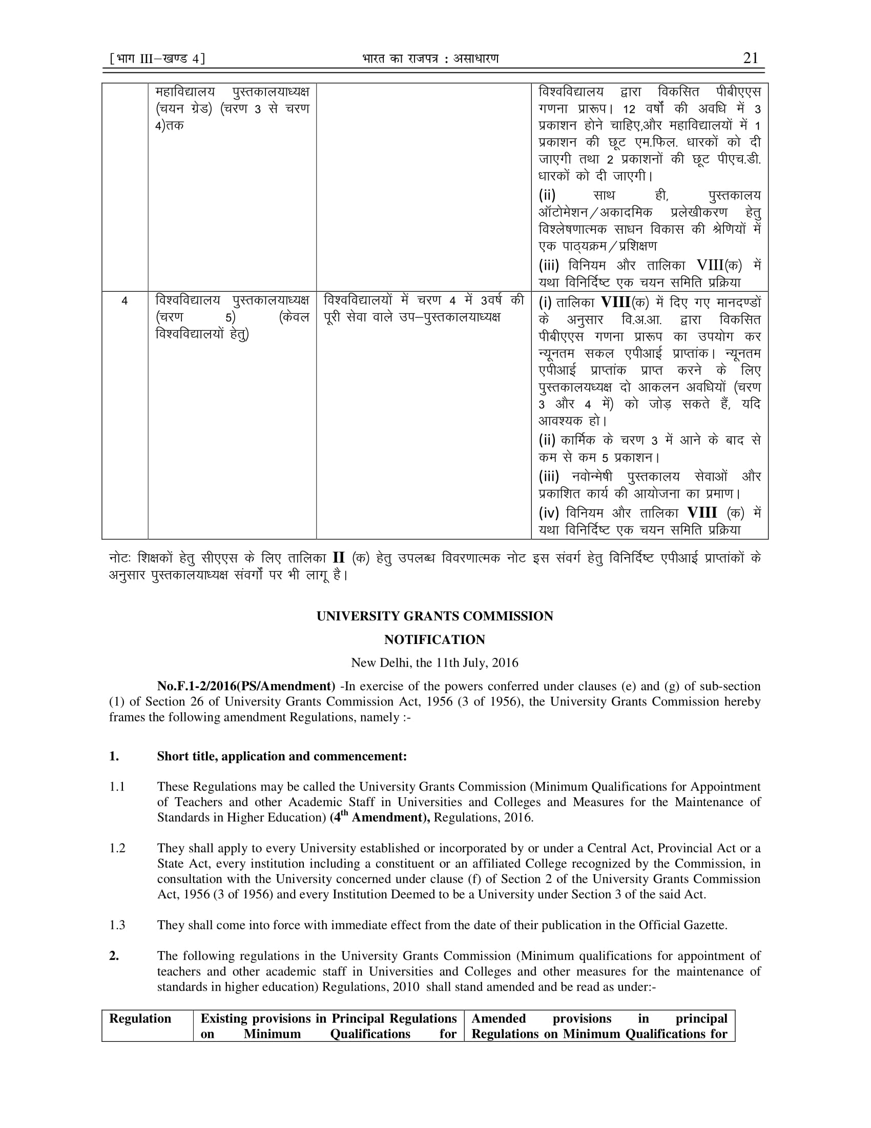
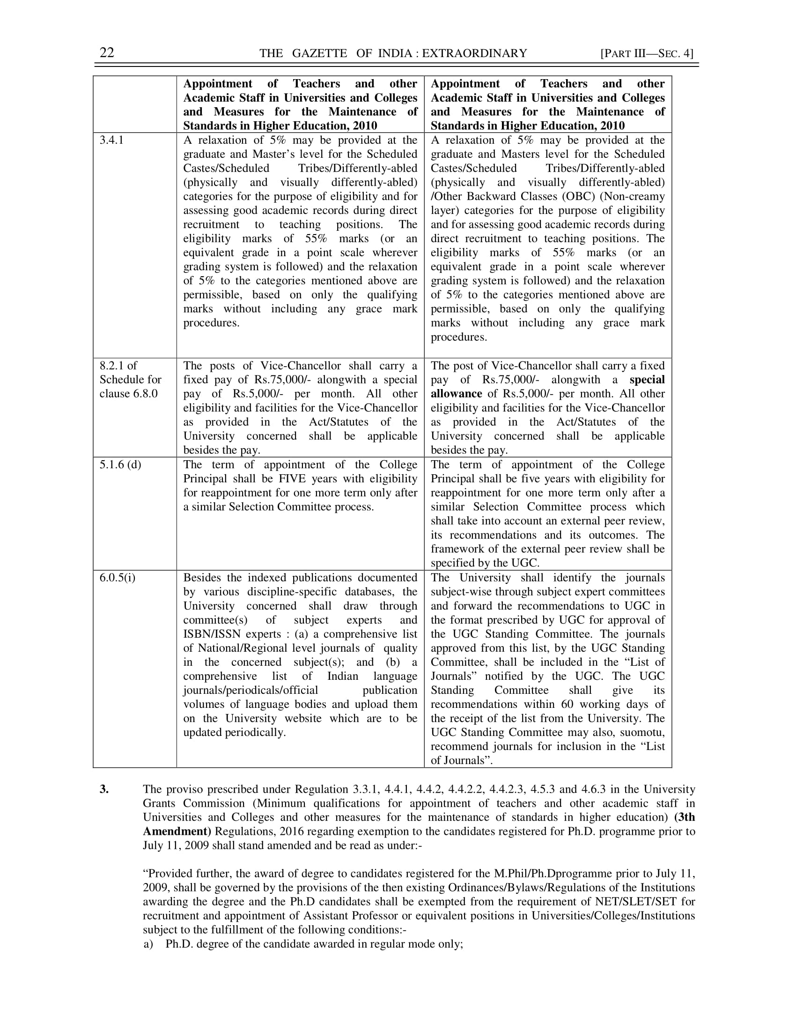
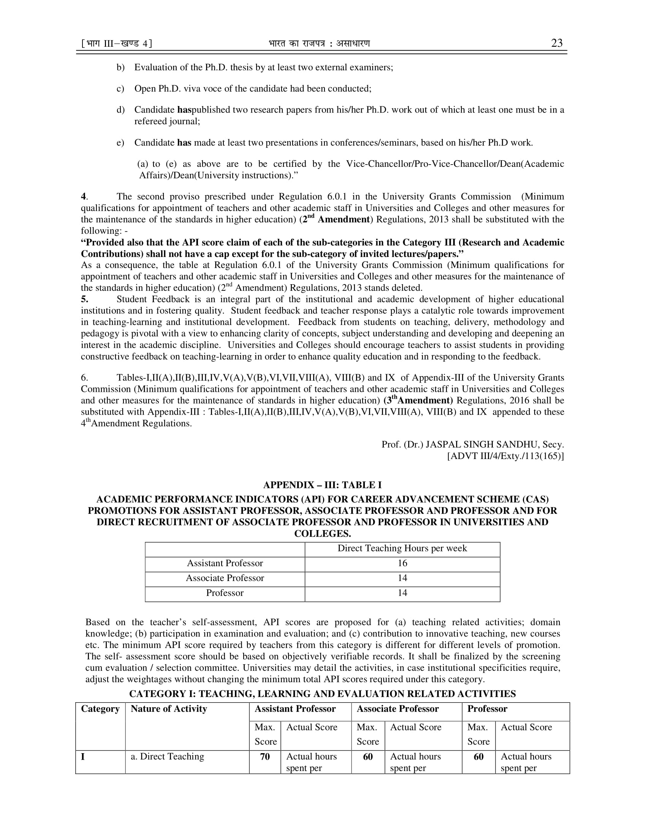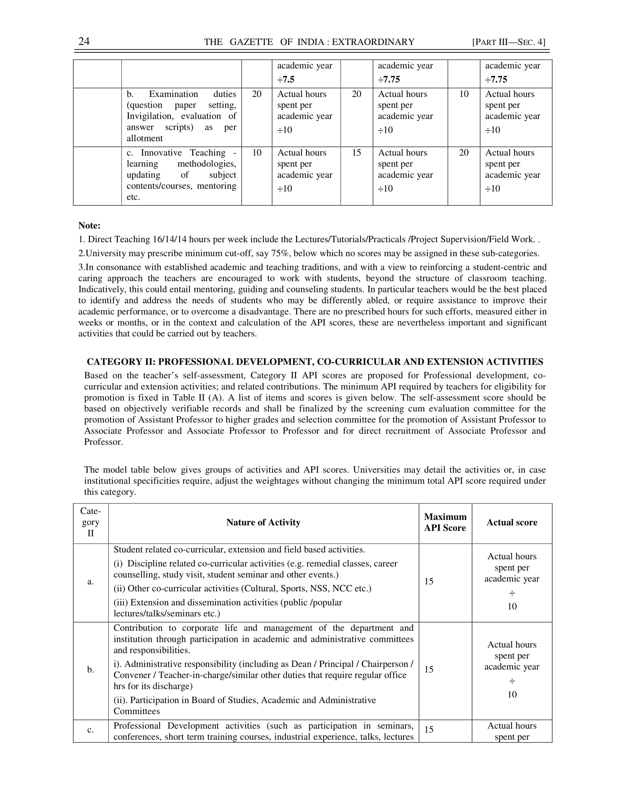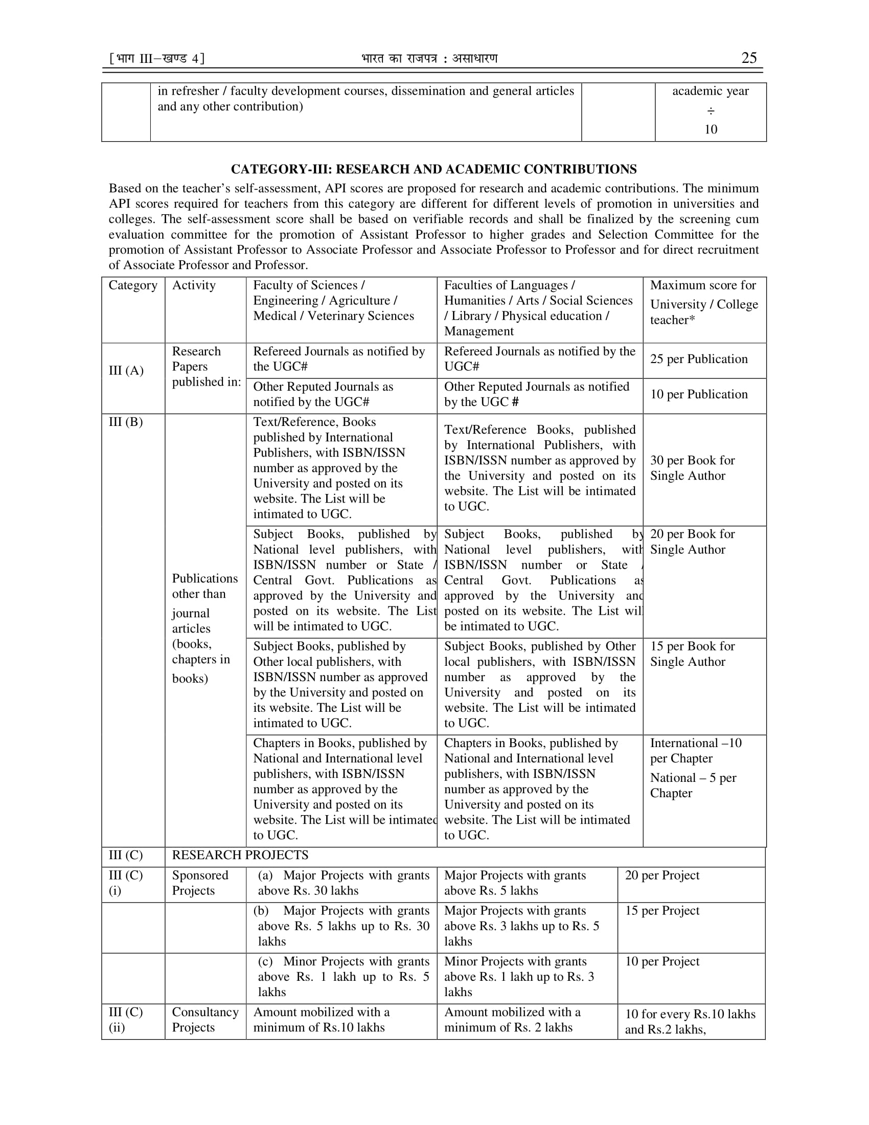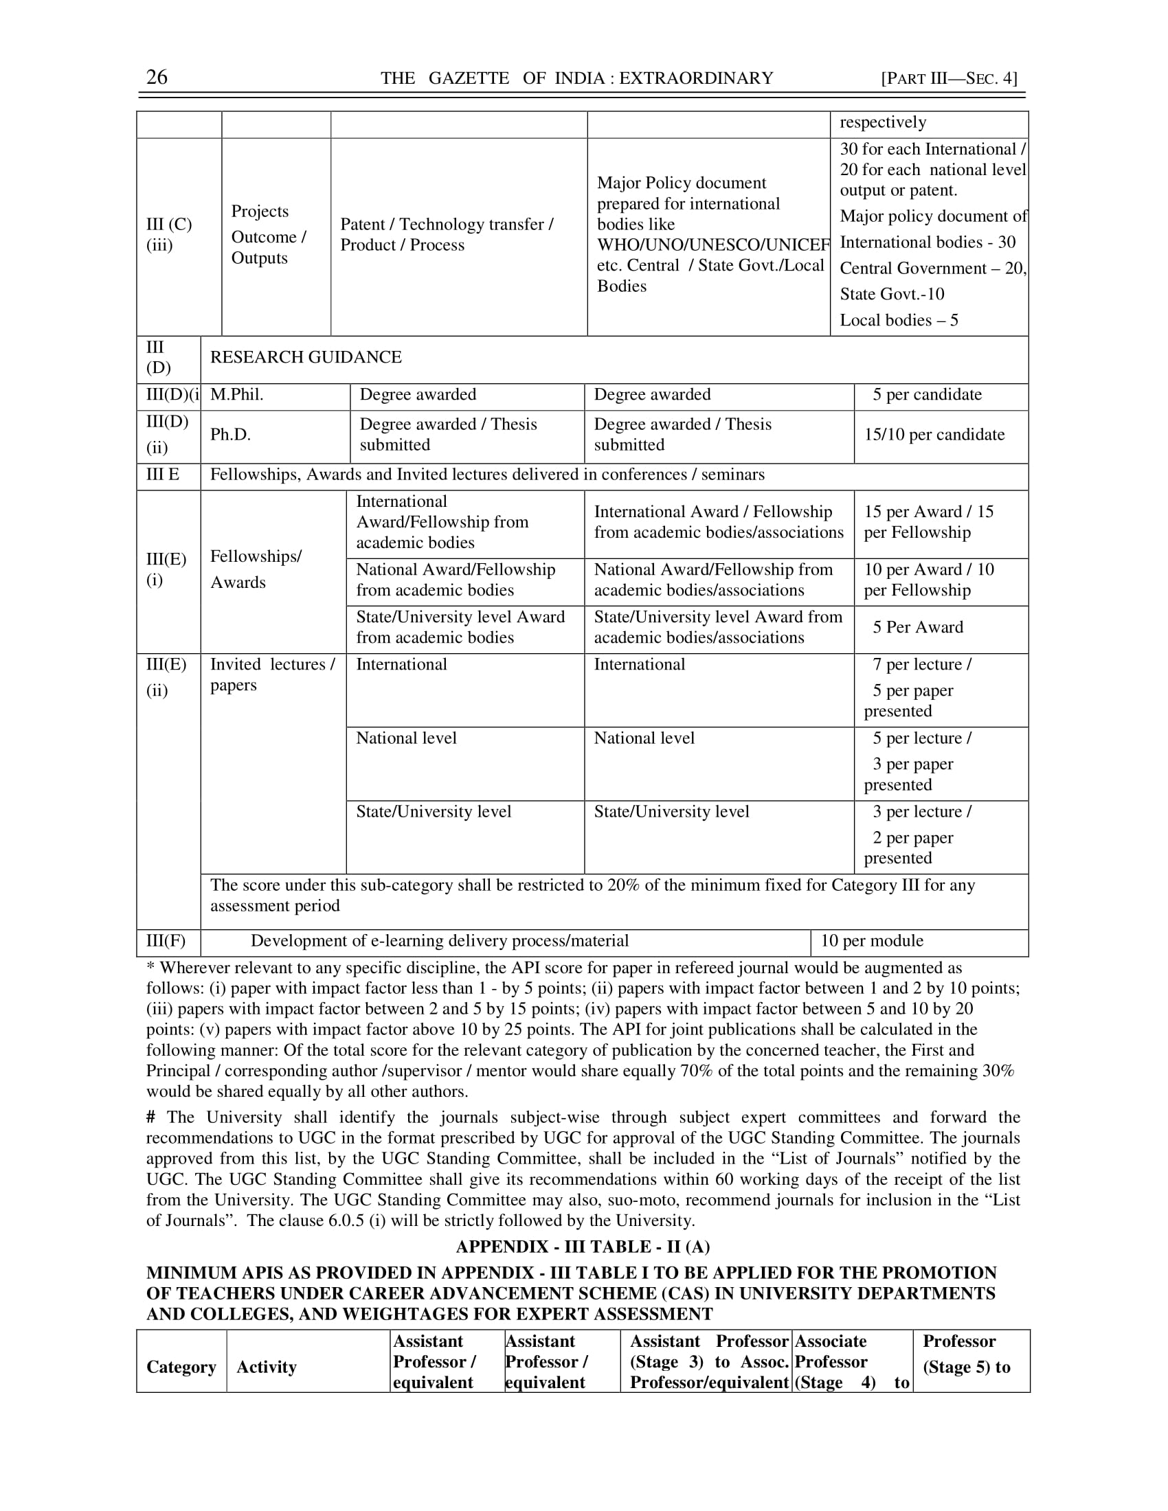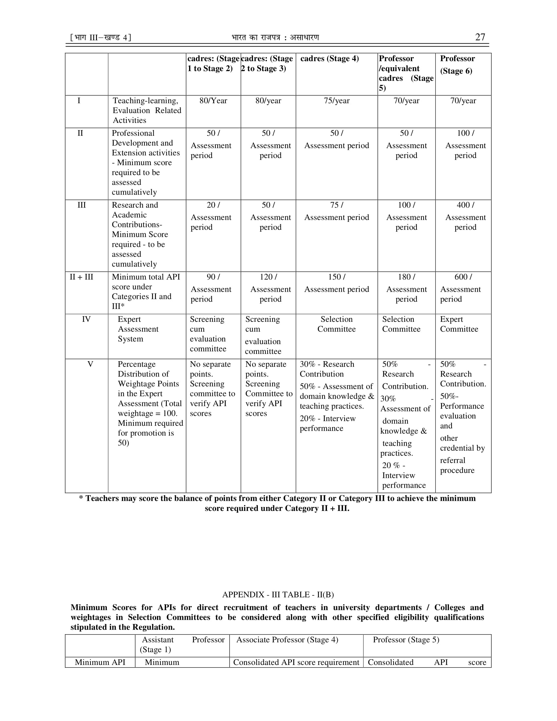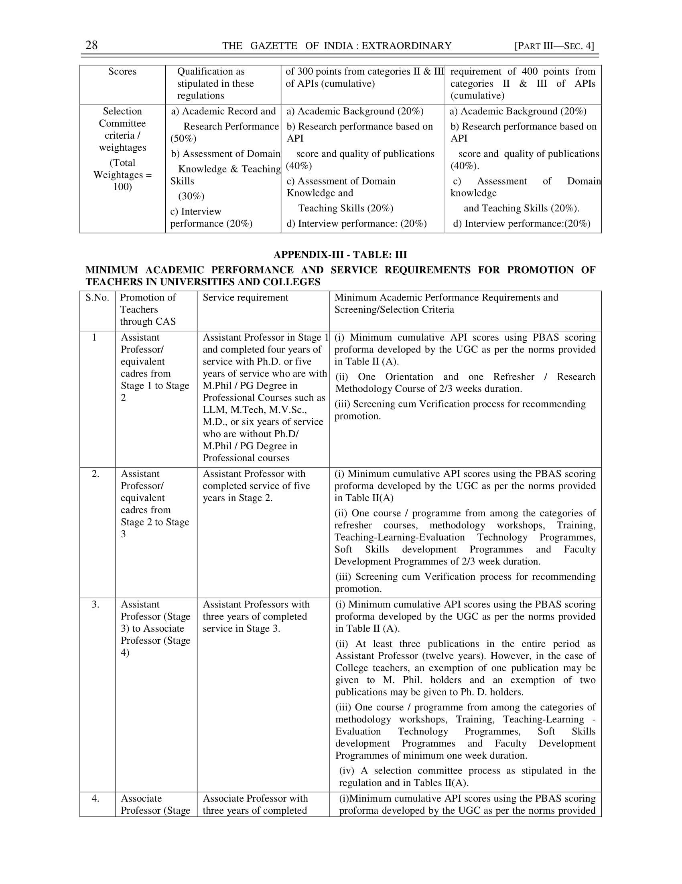
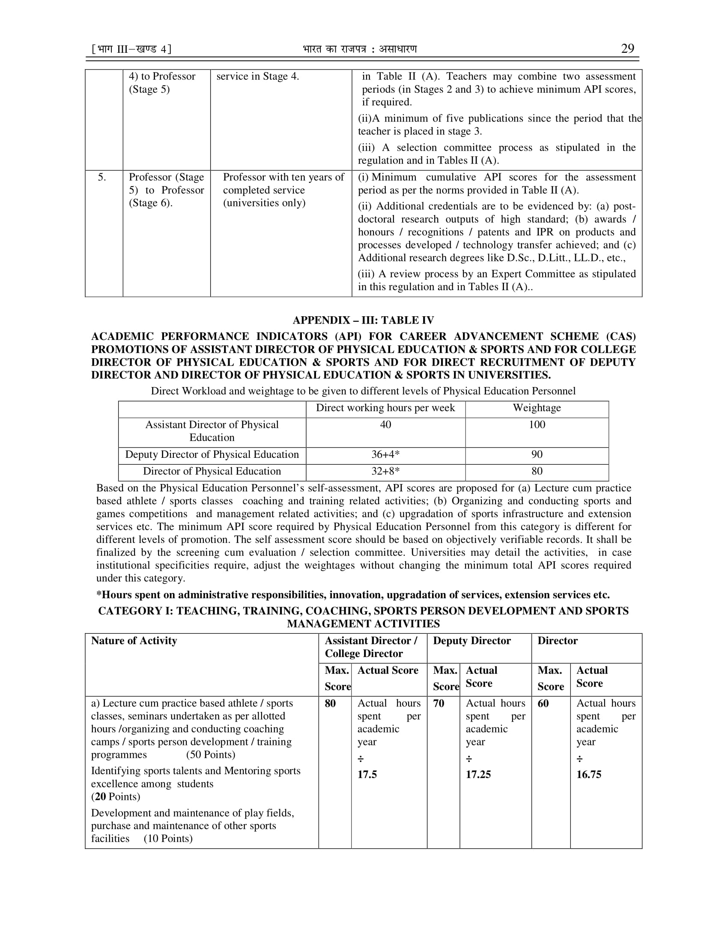

Annexure II
API calculations As Per UGC Guidelines in Annexure I with following Clarifications
S.No. | Activity | Clarification
1. | Joint publications (in journals and conference proceedings) | -When the first author is also the corresponding author or supervisor or mentor, the UGC guidelines will be followed.  - When corresponding author or supervisor or mentor is/are different from the first author, the UGC guidelines will be followed with the clarification that the remaining 40% would be shared equally by all authors.  - When the corresponding author is not identifiable, the UGC guidelines will be followed with clarification that the first author be treated as the corresponding author.  - The benefit of being supervisor will be given on the basis of documentary evidence of the other author having written the article in his or her capacity as research scholar or ME student.
2. | Sponsored Research Projects | The API score for research project will be shared as per the guidelines for research publication with Principal Investigator (PI) being equivalent to first and corresponding author i.e. 60% to the PI and 40% equally among co PIs.
3. | Consultancy Projects | The API score for shared consultancy will be shared in the proportion of monetary distribution under the job.
4. | Research Guidance | The API score for PhD/Mtech thesis guidance will be shared as per the UGC guidelines for research publications with main guide being equivalent to first and corresponding author i.e. 60% to main guide and 40% shared equally among all other co-guides.
5. | Invited Lectures and Chairmanship in Conference/ seminars | The invited lectures and chairmanship in international and national level conference/ symposia only, will be considered for awarding API scores.

